

**Department of Computer Science and Mathematics**

**CSC 491: Professional Experience**

Instructor:

Dr. Ramzi Haraty

Done by:

Nour Jalloul

Date: 1 August 2024

# Acknowledgement

Starting in June 2024, I undertook my internship at Areeba as part of completing my BS degree in Computer Science. The professional atmosphere at Areeba, characterized by commitment and hard work among developers, significantly contributed to my growth. The experience was invaluable, allowing me to gain important skills and knowledge.

I would like to thank Dr. Ramzi Haraty for his assistance and guidance throughout the course. I extend my appreciation to the faculty of the Department of Computer Science and Mathematics for their continuous support and for providing me with the academic foundation necessary to succeed in this internship.

Additionally, I would like to express my sincere gratitude to Areeba for this opportunity. Special thanks to Mr. Wajeeh Zantoot and Mr. Ali Berro for their guidance and support, which helped me build a solid foundation in web development. Their expertise has been instrumental to my learning and professional development.

Lastly, I am also grateful to the entire team at Areeba for their warm welcome and for creating an enjoyable and educational internship experience.

Contents

I. Acknowledgement 2

II. Abstract 4

III. Integrated Digital Systems: About the Company 5

IV. About the Internship 5

V. The Technical Skills 6

(i). Assignments 6

(a). Assignment 1 and 2 6

(b). Assignment 3 8

(c). Assignment 4 9

(d). Assignment 5 10

(e). Assignment 6 12

(ii). Final Project 14

VI. The Soft Skills 22

(i). Communication Skills 22

(ii). Self-Learning 22

VII. University Courses Used in the Internship 22

CSC 375 Databases Management Systems: 22

CSC 490 Software Engineering: 23

VIII. Future Expectations 23

IX. Conclusion 23

1. Letter of Intent……………………………………………………………………..…….25
2. Training Certificate…………………………………………………………………...……27
3. Employer's Signiture…………………………………………………………………….....28
4. References ………………………………………………………………………………..29

# Abstract

As part of the computer science program at [Your University], students are prepared to engage with real-world challenges and to apply their academic learning in a professional setting. The internship program is designed to bridge the gap between theoretical knowledge and practical experience, equipping students with the skills needed for their future careers in technology.

During my internship at Areeba, which took place from June to July 2024, I had the opportunity to both learn new skills and apply the knowledge acquired during my university studies. The internship involved working on various web development projects, including the implementation and enhancement of an e-commerce website. I was tasked with making the site responsive, integrating React, Redux, and TypeScript, and implementing CRUD operations with MongoDB.

This experience allowed me to gain hands-on experience in front-end and back-end development, state management, and user input validation. It also provided valuable insights into working collaboratively within a professional team and applying problem-solving skills to real-world challenges. The internship not only enhanced my technical capabilities but also refined my ability to navigate a professional environment.

This report highlights the different assignments and the final project undertaken during my internship, showcasing how both new and previously acquired skills were utilized in achieving project objectives and contributing to professional growth.

# Areeba

**{/\*** IDS, which stands for Integrated Digital Systems, is a leading software development company that provides Enterprise Resource Planning (ERP) products, Archiving Solutions, Document Management, Wealth Management, Online Trading, e-commerce, and e-government solution. The company designs and develops mobile applications and websites that assists business in acknowledging the power of data, social collaboration, cloud computing, and next generation tools for the enterprises (IDS,2018). The company is part of the Microsoft Partner Network and has been a Microsoft Certified Partner since 2001(IDS,2018). IDS builds programs that tackle business issues and strengths the use of technology to empower organizations to work all the more proficiently with more visibility and control over the supply chain. **\*/}**

**{/\***

Areeba is a leading technology company specializing in providing innovative solutions in the digital space. Established with the vision of transforming the technology landscape, Areeba is committed to delivering cutting-edge products and services that address the evolving needs of the industry.

The company’s mission is to empower businesses through technology by offering a range of services including software development, web development, and IT consultancy. Areeba focuses on leveraging the latest technologies to create scalable and efficient solutions that drive growth and success for its clients.

Areeba’s team of skilled professionals is dedicated to fostering a collaborative and dynamic work environment. The company emphasizes continuous learning and professional development, making it an ideal place for interns to gain practical experience and contribute to meaningful projects.

During my internship at Areeba, I had the opportunity to work on various web development projects, including implementing and enhancing an e-commerce website. This experience provided me with valuable insights into the company’s operations and the technology industry, furthering my understanding of professional practices and technological advancements.

**\*/}**

**//or use the linkedIn’s about**

# About the Internship

**{/\***The internship was a three months’ online internship about web programming using visual studio, where different assignments were posted to us via a forum online, explaining what we should do and providing different useful resources to learn form. The forum was a meeting point between the interns, where we switched knowledge between each other, in addition to being a bridge between the interns and the employees at the company where we could ask whatever wasn’t clear or what we couldn’t do. We also had to pass by once every week to present what we have done and discuss different ways of improving it. After being assigned different assignments during the first 2 months, a project was given in which we applied on all what has been learned.

**\*/}**

My internship at Areeba was a dynamic and hands-on experience in web development, spanning from June to July 2024. The internship was designed to immerse me in real-world web programming tasks and to provide practical experience with modern technologies.

The internship involved working on various assignments, which were provided through a collaborative platform. This platform served as a central hub for communication among interns, where we exchanged knowledge and collaborated on problem-solving. It also facilitated interaction with company employees, allowing us to seek guidance and clarify any uncertainties.

During the first part of the internship, I was tasked with implementing a home page for an e-commerce website based on a Figma design, and later worked on making the site responsive across different screen sizes. As I progressed, I continued to develop my skills in JavaScript, React, Redux, and TypeScript through a series of assignments and self-directed learning.

Each week, we were required to present our progress and discuss potential improvements with mentors and peers. This regular feedback loop helped refine our work and enhance our technical skills.

In the final phase of the internship, I applied everything I had learned to a comprehensive project. This project involved integrating CRUD operations with MongoDB and connecting the frontend with a backend server, demonstrating the practical application of the skills acquired throughout the internship.

Overall, the internship at Areeba provided a valuable opportunity to bridge academic learning with practical experience, contributing to both my professional development and my understanding of the technology industry.

# The Technical Skills

### (i)Assignments:

**In our assignments, we were taught about back end developing of websites and didn’t really focus on the design part.**

#### (a) Assignments 1 and 2:

In our first lesson we were taught how to use both HTML and CSS when building up a website. Since I had no experience in web programming, I went on to learn it using w3schools and YouTube videos. I figured out how html language builds up the different content of the webpage and how it divides it into different parts and how a website can be chopped into different sections and each section can be managed. However, I figured out that the design part is missing and so we must use css in order to refine the shape of the website and add a texture to the website. So, for our first assignment, we had to design a CV webpage which must include a header, a footer, a picture, a list, and of course formatted text. Through what I have learned, I managed to build a responsive front end, which contains 4 different sections, an introduction, my skills, my interests and a contact me form, each with different types of designs using css. Also, we were asked to host our website on google drive, and so I did by creating a public folder on Google Drive and uploading the html and css files and then previewing them and getting the URL address.

As for the second lesson, we were taught how to use jquery and javascript which allow us to add action to our website and traverse it properly. In order to practice what we learned, we were asked to add a tab system to switch between sections, an animated slider and a contact me form. What I have done is using these languages to create a navigation bar on top of the page which when pressed on one takes you to the proper section and that’s by using jquery.

|  |  |  |
| --- | --- | --- |
| <script>  $( **function**() {  $( "#tabs" ).tabs();  } );  </script> | | |
|  | Also, for creating the animation slider, I also used jquery in order to slide the images, where the |  |

division of the slider and that’s by loading jQuery simple slideshow library. As for the contact me form, we were required to validate the input by using javaScript functions which checks if fields are empty and if there were any other errors. At the end of lesson 2 we were asked to recap about what we have learned.

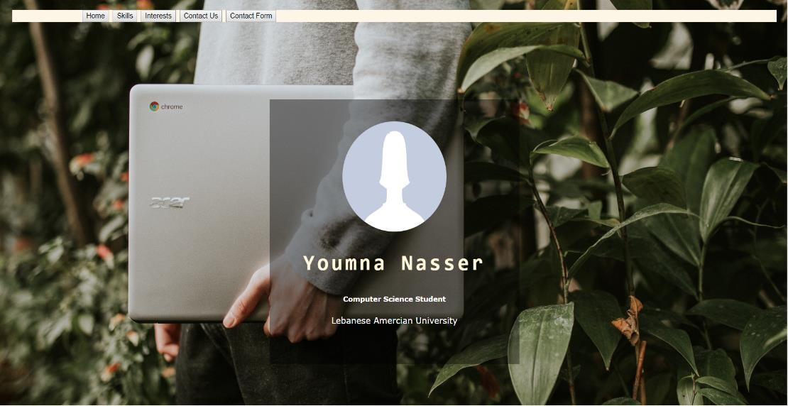

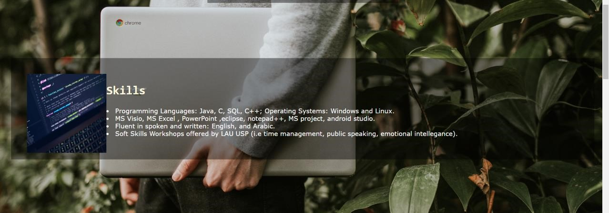

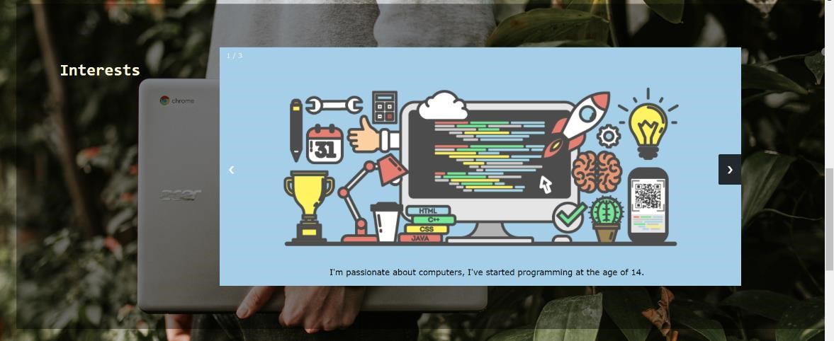

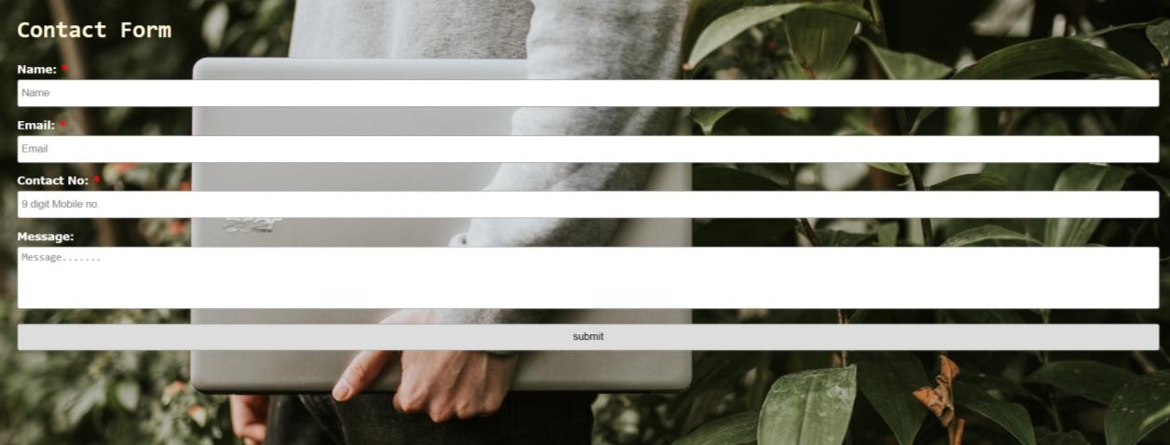



##### (b) Assignment 3:

In assignment 3, we had to learn about SQL language, but since I’ve already taken the database course, there was no need to learn it again. We were also asked to design our own database using Microsoft SQL Server. We must build the tables, that contain both foreign and primary keys and generate ER diagram, then fill the database with data. For creating the tables, CREATE function was used, and for setting the primary key PRIMARY KEY attribute was used, as for the foreign key FOREIGN KEY attribute, and INSERT function for inserting data.

Example on CREATE:

CREATE TABLE [dbo].[Address](

[add_id] [int] NOT NULL,

[loc_id] [int] NOT NULL,

[cand_id] [int] NOT NULL,

CONSTRAINT [PK_Address] PRIMARY KEY CLUSTERED

CONSTRAINT [FK_Address_Address] FOREIGN KEY([add_id])

REFERENCES [dbo].[location] ([loc_id])

CONSTRAINT [FK_Address_Candidate] FOREIGN KEY([cand_id])

REFERENCES [dbo].[Candidate] ([can_id])

Example on INSERT:

INSERT [dbo].[References] ([cand_id], [ref_id], [ref_name],

[ref_position], [ref_email], [ref_phone]) VALUES (1, 1, N'Youmna Nasser',

N'Student', N'youmna.nasser@lau.edu', N'76160365')

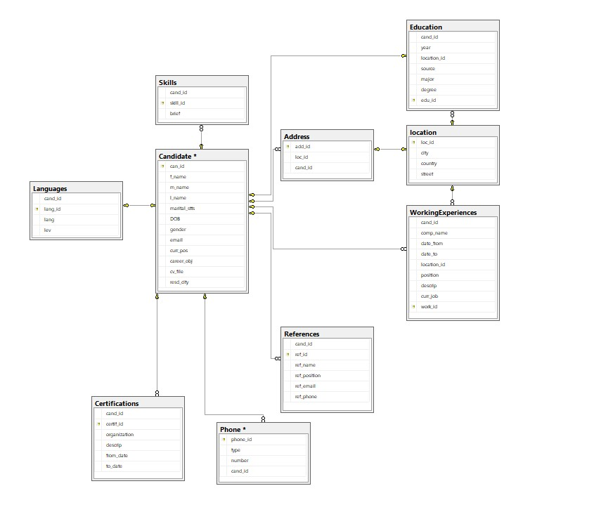

###### (c) Assignment 4:

In our 4th lesson, we had to learn about entity framework, We had to transform our database into objects to make our coding easier and that was done using the Entity Framework under Microsoft Visual Studio. Entity Framework allows the developers to work with their data stored in the database using objects of domain specific classes without concentrating on the underlying database’s tables that keeps the actual data.

We were asked to create a simple webpage (.aspx) using C# or VB, open a

connection with the database from the aspx page, and show the list of candidates added to the database with displaying the results in this webpage.

First, to create a simple webpage (.aspx) this could be done by creating a new project, selecting Visual C# >> Web >> ASP.NET Web Application, and that can also be done by adjusting the connection string in the in Web.config file. As for establishing a connection from the database, this could be manually by adding a new item to the webpage that is the SQL Server Database. As for displaying the candidate, we tried doing it in 2 ways, either with a repeater class, that creates a new entites(), which resembles the database connection that gets the tables in the database, and applying a query that gets the information from the table, all are gotten as a form of tolist(), then binding it to a repeater. Another way would be explicitly creating a grid view.

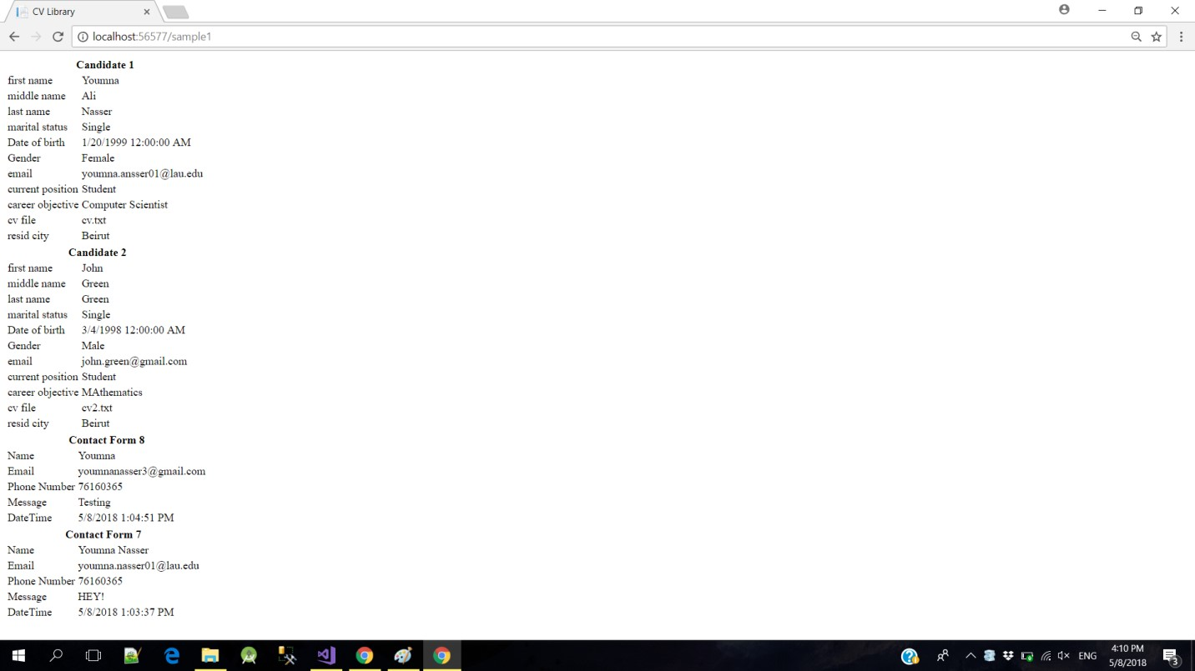

(d) Assignment 5:

In this assignment, we were asked to learn about ASP Membership provider, that adds security and permissions to the website. ASP membership provider enables the developers to have a unique account, with a username and a password. This feature requires having a connection with SQLServer to store user information. So, we were requested to add user/admin role to the users registered, add a page to manage the registered users, and give them the desired permissions (Admin role or User role), create a page to manage the candidates in the database that shows a grid view that also previews the options of creating or editing or deleting candidates, in addition to add permissions to "Manage candidate" page & "Manage Users", where only admins can see this page.

In order to set up the asp membership provider, we learned to enter “aspnet_regsql” in the command line prompt and manage things up from here, this will manage in creating additional tables to the database that are necessary for authentication. As for the login/register webpage, it will be explicitly designed by the visual studio, and it could be done easily by using database entities’ build-in function Add, and querying to check if username and password exit and match in login procedures.

What I have done to assign roles and manage user’s info and put permissions, is that I created a controller that contains different methods for different purposes. A method was written which directs the user into another page to assign roles to the users which is authorized to only admins through [Authorize(Roles=”admin”)]. Whenever the admin clicks on the button corresponding to this page, a new View is created which is a .cshtml that corresponds using the following code the name with a role.

@using (Html.BeginForm("RoleAddToUser", "Roles"))

{

@Html.AntiForgeryToken()

@Html.ValidationSummary(true)

<p>

Username : @Html.TextBox("UserName")

Role Name: @Html.DropDownList("RoleName", (IEnumerable<SelectListItem>)ViewBag.Roles,

"Select ...")

</p>

<input type="submit" value="Save" />

}

As mentioned previously, in order to give permissions to the methods I used

[Authorize(Roles=”admin”)], as for the grid view, it could be dragged and dropped, and then linked to the entities by choosing data source. Also, adding/deleting/editing users could also be added by auto generating these options.

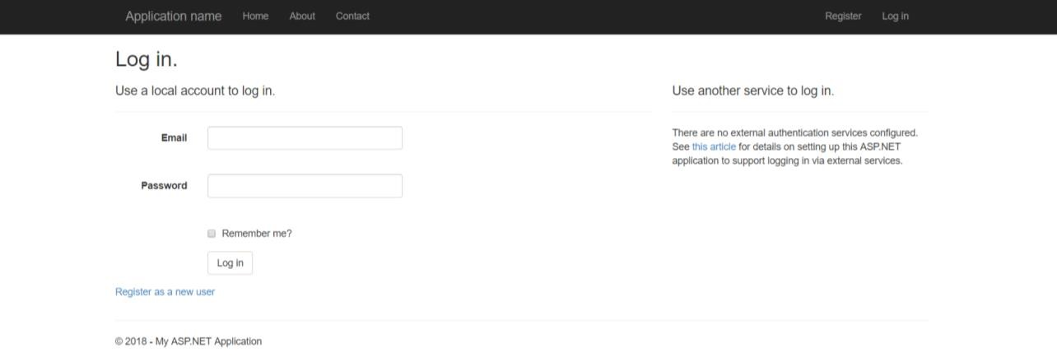

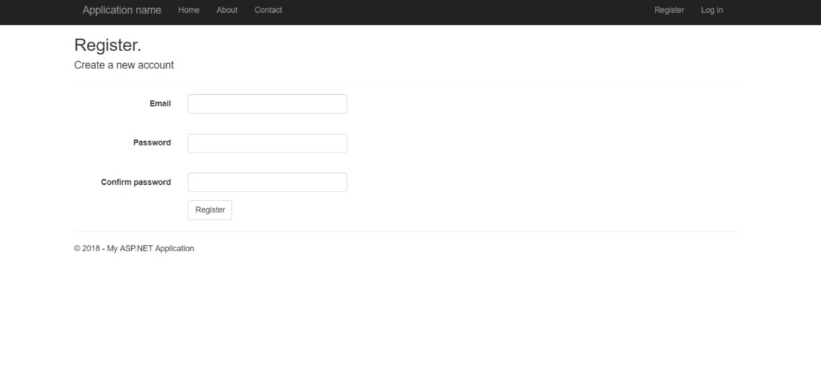

#### (e) Assignment 6:

In our last assignment, we learnt about Web Services. Web Services are used to provide communication between different web applications. We had to use web services in this assignment by using ajax. We have learnt that ajax stands for Asynchronous [JavaScript](https://skillcrush.com/2018/04/16/javascript-jobs/) and XML. Using web services helps in reducing the post backs in the webpage in addition to reducing the time waiting to get data and to update it. For testing this service, we were requested to create a web service to get the list of Candidates in addition to the Candidate details by sending the Candidate Id to the service. We were also asked to use the created web-services in the backend pages already created before and load Candidate data using the web-service and manage their information using the related methods. This was done by adding a web service page that includes the methods to get the candidates information. In order to be able to use the web service in the backend pages already created, javascript functions had to be implemented, that get the candidate by id, receives result from the webpage successfully and another one that receives errors from web service.

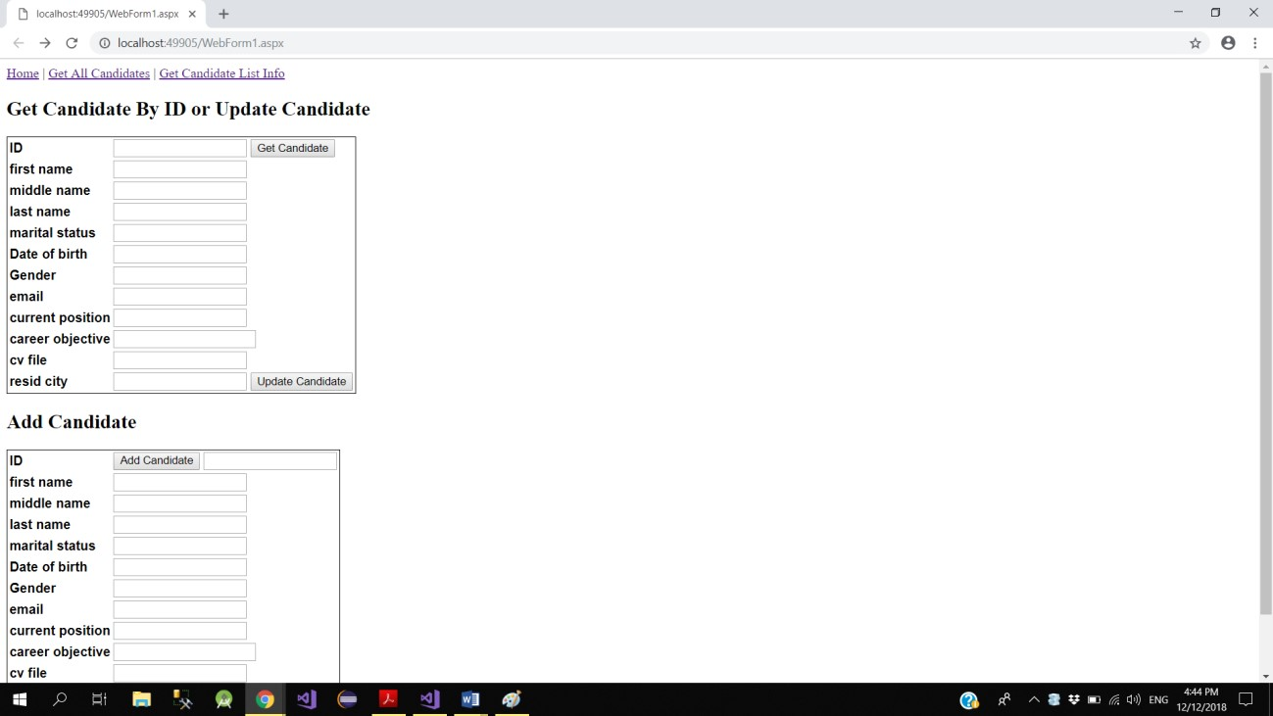

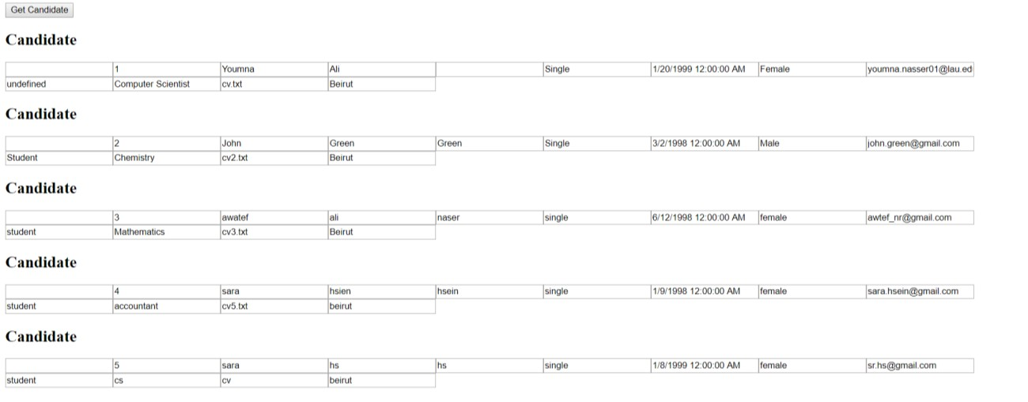

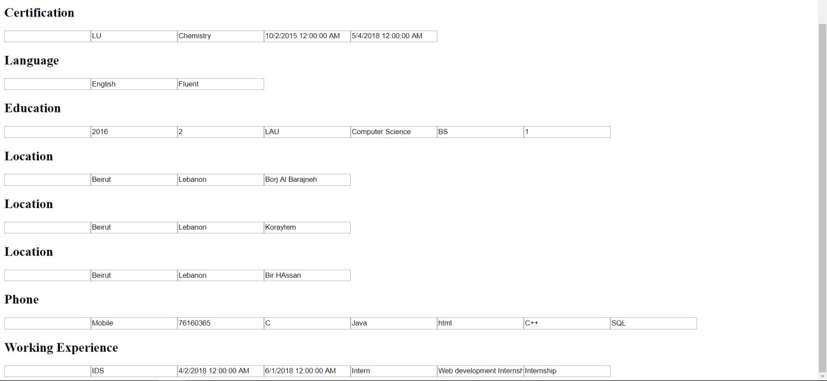

Web service:

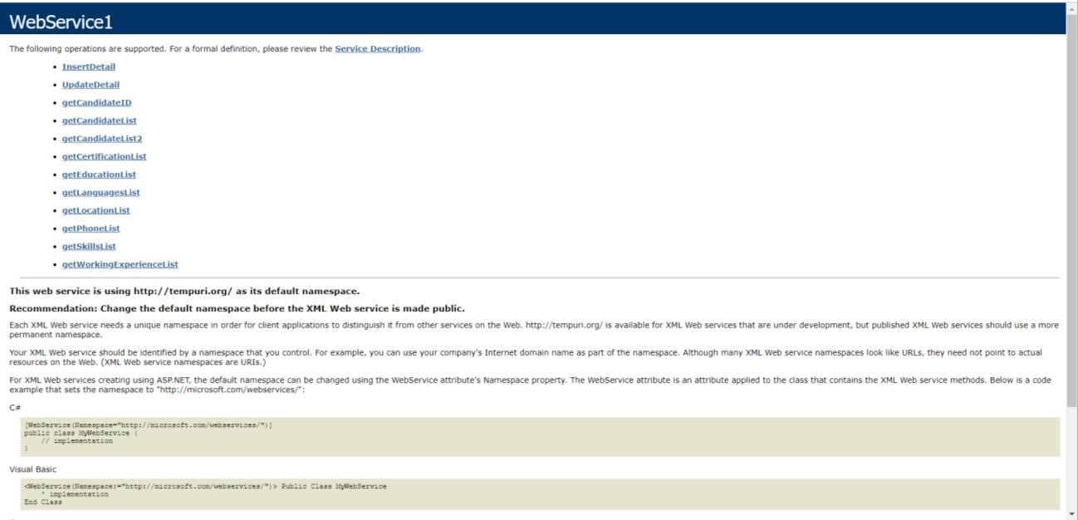

### (ii) Final Project:

In the final project, I was asked to implement an attendance management program with specific features in which everything that was taught gets covered in this final project.

The design phase starts by planning an overall picture of how the system will be, what will it include, the webpages and how they will be related. It first started by creating the database using sql server, that included information about every registered user and the activities done during his login session. The database consists of

1-users table, that mainly includes his email, password, name, role, job and department, stores the information of the employee/manager

2-roles table: roleid, rolename, that assigns roles

3-department: department name and id

4-job: jobname and id

5-employee working: Name, date, time in, time out, comment, id, email, duration, address, which stores real time information of checks in and out done by the user

6-address: addres name, location X, location Y

7-working day: email, total working hours, starting time of the day, ending time of the day, which stores the daily information of every user

8-holiday: starting time, ending time, total working hours, which puts the time limits for throughout the system

9-holidays: date of the holiday, which sets the holidays in which the employee isn’t allowed to work in

The work then starts using Visual Studio 2017, as I start by working on the asp membership provider, which ensures a registration and login pages, the same implementation way as mentioned above. Then, I start working on the record real time attendance page, where I worked on putting a clock in addition to a timer by simply adding it from the toolbox in visual studio in addition to performing other minor changes. This page displays the check in and check out buttons, in addition to a text box with the location suggestion, as it has been implemented with using Ajax autocompletextender control and web service These information are all saved inside the database by using the entities built-in function ADD. Then, I created the grid view that displays the registered users and their real time attendance records. This page was implemented as I did in the assignments, but the difference here is that the delete/add/update options are implemented manually using specific methods which apply the changes using database entities., for example when deleting:

int employeeid = (int)myGridview.DataKeys[e.RowIndex]["Employeeid"]; using (MyDatabaseEntities dc = new MyDatabaseEntities())

{

var v = dc.Employees.Where(a =>

a.Employeeid.Equals(employeeid)).FirstOrDefault();

if (v != null)

{

dc.Employees.Remove(v); dc.SaveChanges();

PopulateContacts();

}

}

In addition, a page was also created in order to manage the time limits that are set by the company and the days that are set as holidays. This was done by adding a calendar control from the tool bar in addition implementing the methods needed in order to highlight the holidays. Moreover, an address management page was also created that lets the managers set the addresses in which the employees can go to. In addition, a vertical side bar was implemented with a normal html page.

Registering:

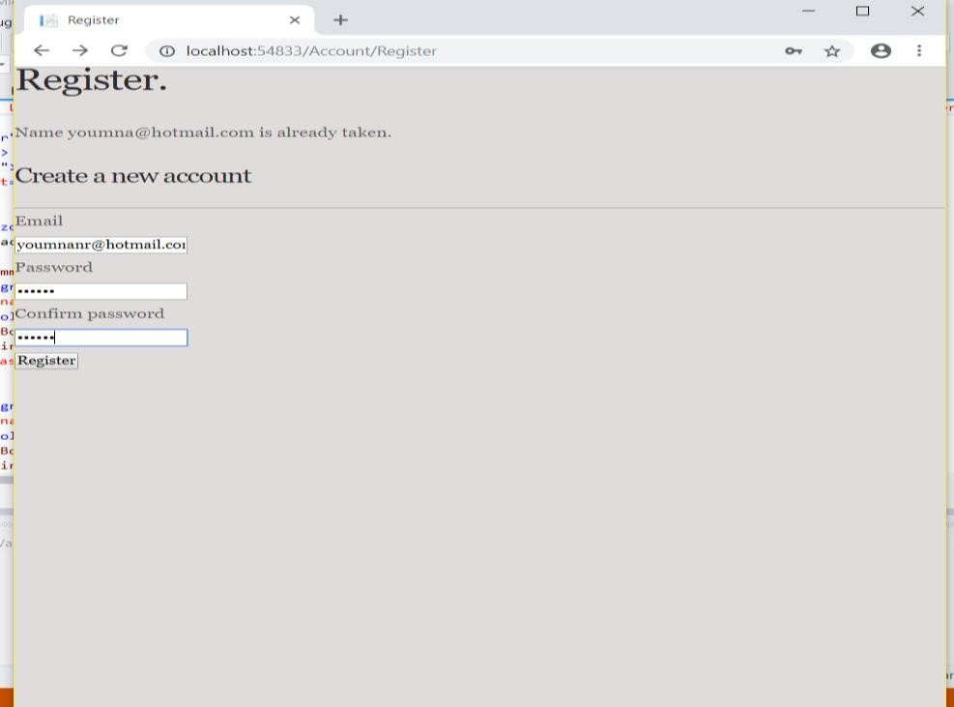

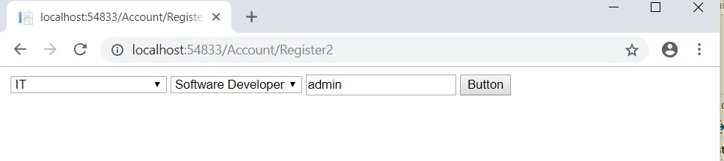

Logging in:

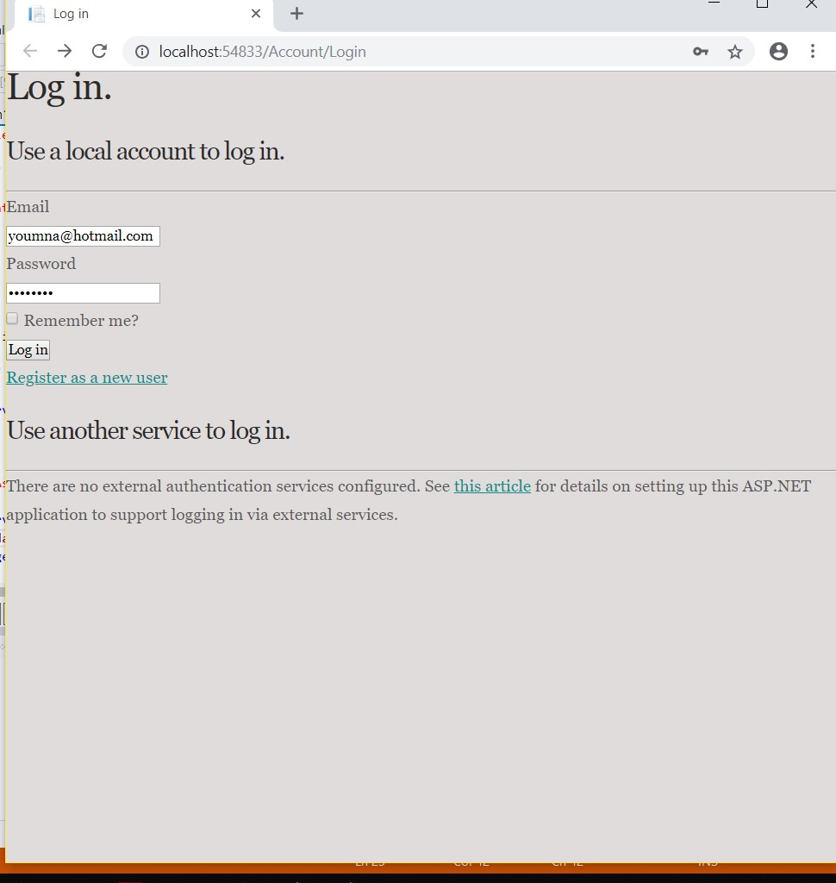

If logged in as a manger:

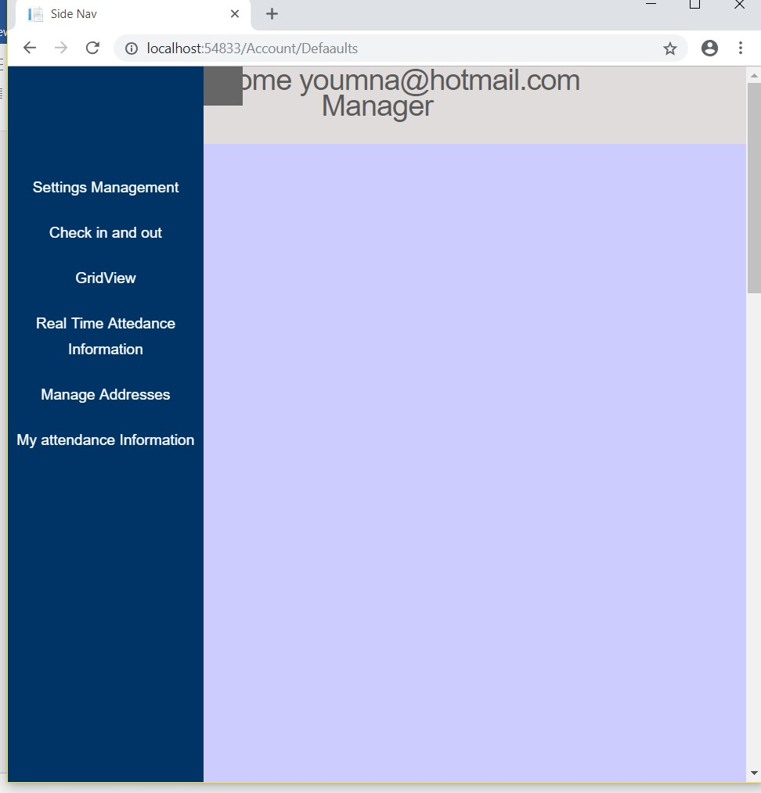

While logging in as an employee shows the following:

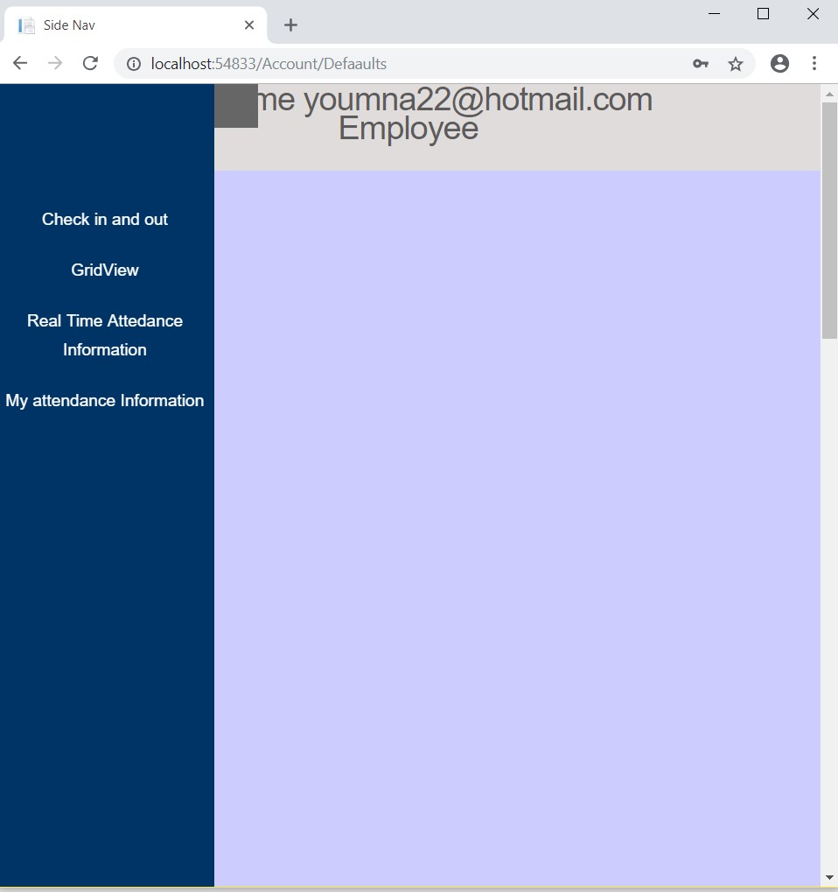

Checking in and out:

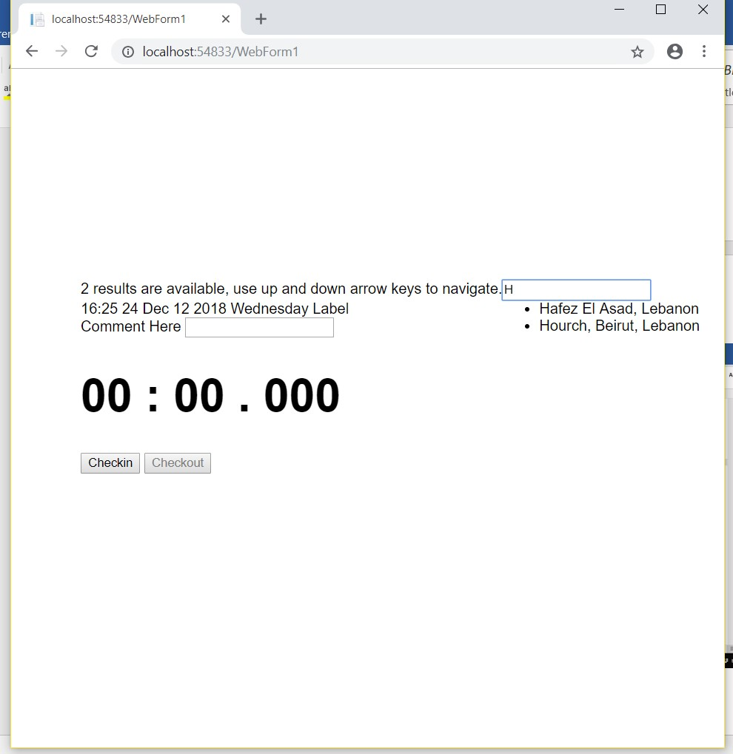

Settings Management:

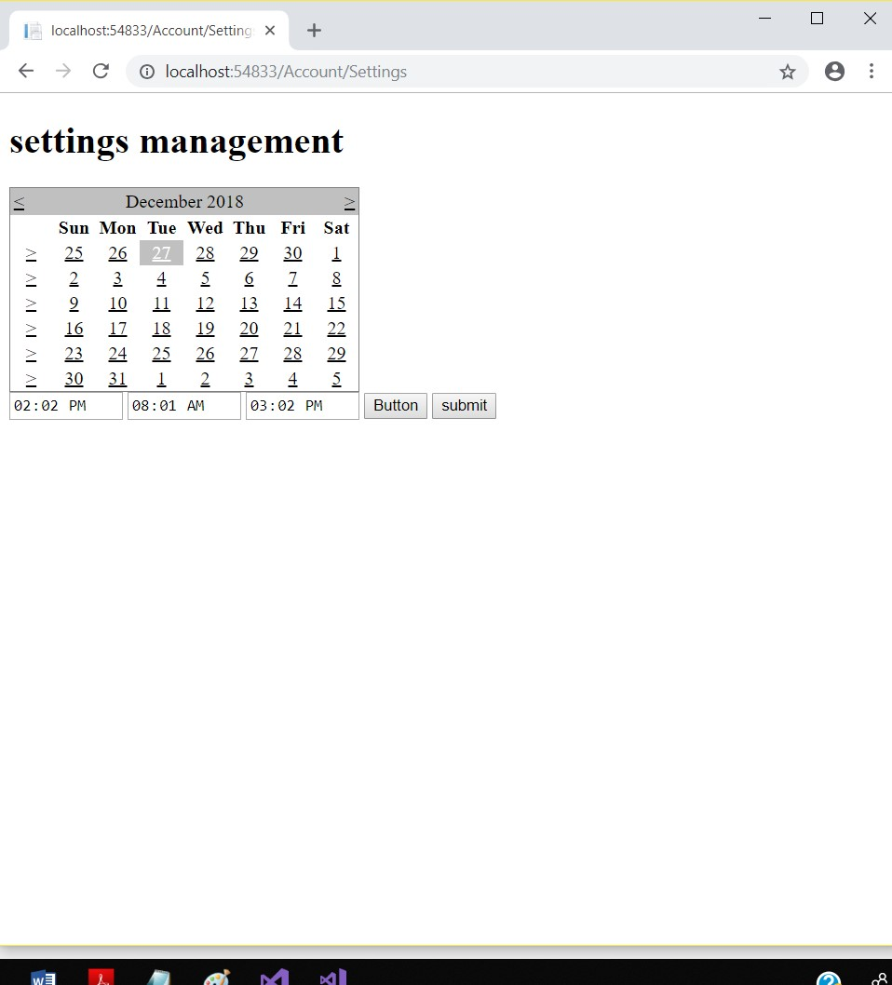

Manage Addresses:

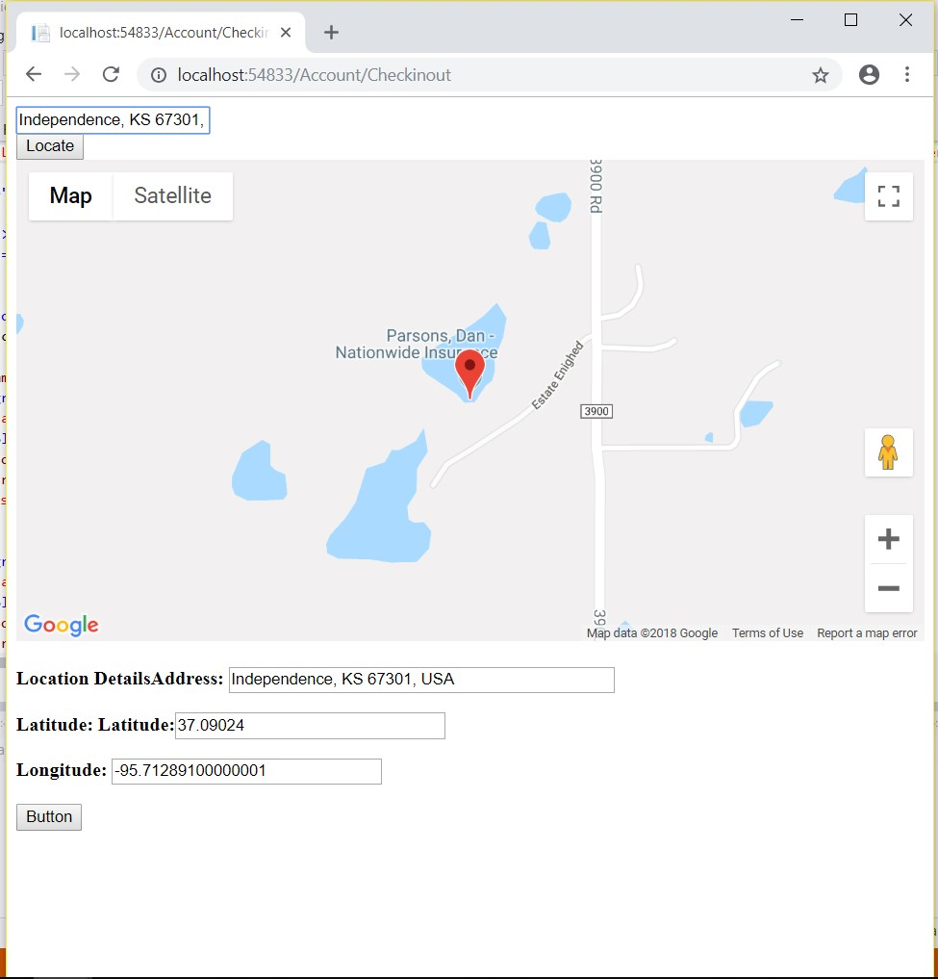

Showing personal information:

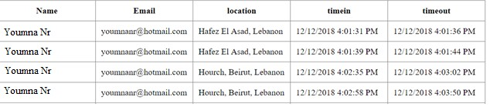

List of Employees:

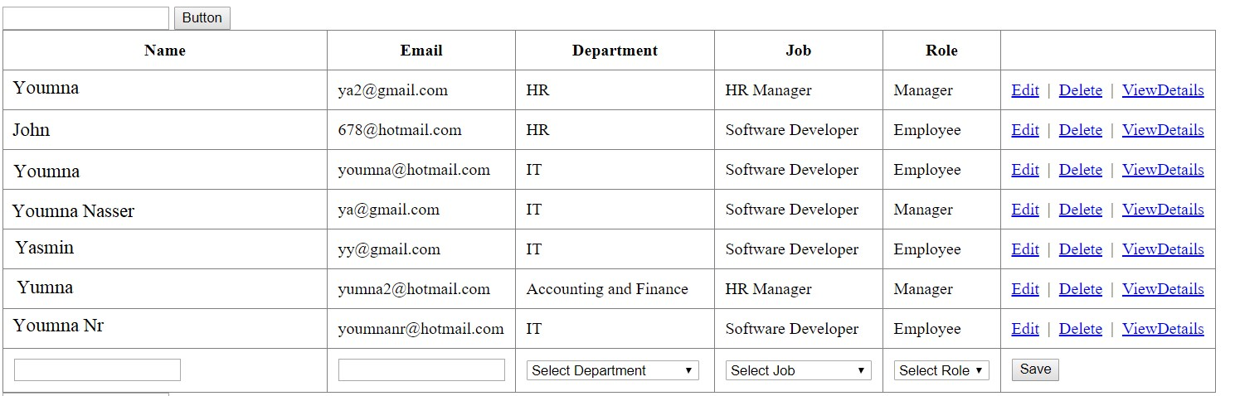

Showing the user’s today check in and out:



### V. The Technical Skills

**(i). Assignments**

Throughout my internship at Areeba, I engaged in a variety of assignments that expanded my technical skills and practical knowledge. Below is an overview of these assignments and the skills I acquired.

**(a). Assignment 1: Web Page Development**

* **Description:** Created a CV webpage incorporating essential web components such as headers, footers, images, lists, and formatted text.
* **Technologies Used:** HTML, CSS.
* **Skills Acquired:** Developed skills in structuring web pages with HTML and enhancing their appearance with CSS. Created a responsive layout with multiple sections, including an introduction, skills, interests, and a contact form. Learned to host and preview the website using Google Drive.

**(b). Assignment 2: Interactive Features with JavaScript and jQuery**

* **Description:** Added interactive elements such as tab systems, animated sliders, and a contact form with validation.
* **Technologies Used:** JavaScript, jQuery.
* **Skills Acquired:** Gained experience in using jQuery for navigation and animation, and JavaScript for form validation. Implemented a tab system to navigate between sections and an animated image slider.

**(c). Assignment 3: SQL and Database Design**

* **Description:** Designed and implemented a database using Microsoft SQL Server, including creating tables, defining primary and foreign keys, and populating the database with data.
* **Technologies Used:** SQL Server, SQL.
* **Skills Acquired:** Learned to create and manage databases, construct SQL queries for data manipulation, and use ER diagrams for database design.

**(d). Assignment 4: Entity Framework and ASP.NET Web Pages**

* **Description:** Used Entity Framework to interact with a database through object-oriented programming. Created a web page to display and manage database information.
* **Technologies Used:** Entity Framework, ASP.NET, C#.
* **Skills Acquired:** Mastered the use of Entity Framework for database operations and developed ASP.NET web pages to interact with data. Implemented features to display candidate information using a repeater class and grid view.

**(e). Assignment 5: ASP Membership Provider**

* **Description:** Implemented user authentication and role management using ASP Membership Provider. Developed pages for user and role management with access control.
* **Technologies Used:** ASP.NET Membership, SQL Server.
* **Skills Acquired:** Learned to set up user roles and permissions, manage user accounts, and secure web pages based on user roles.

**(f). Assignment 6: Web Services and AJAX**

* **Description:** Created web services for data retrieval and integrated them with web pages using AJAX to enhance user experience by reducing page reloads.
* **Technologies Used:** AJAX, Web Services.
* **Skills Acquired:** Implemented web services to fetch and manage data asynchronously. Used AJAX for smooth user interactions and improved data handling efficiency.

**(ii). Final Project: RoboFriends Application**

**Project Overview**

* **Description:** Developed the RoboFriends application, integrating various skills learned throughout the internship into a comprehensive project.
* **Technologies Used:** React, Redux, TypeScript, MongoDB, Express.js.

**Project Details**

* **User Management:** Implemented features for adding, editing, and deleting users. Created a user details page using React Router.
* **API Integration:** Connected the application to a backend server with CRUD operations.
* **Database Integration:** Utilized MongoDB for storing user data and connected it with the backend server.

**Skills Acquired:**

* **Front-End Development:** Advanced React skills, state management with Redux, and TypeScript integration.
* **Back-End Development:** CRUD operations, API development, and MongoDB database management.
* **Project Management:** End-to-end development of a functional web application from design to deployment.

# The Soft Skills

### (i)Communication Skills:

One of the keys in building a good project is being able to well communicate and discuss the problems and the structure of the project with the team. Communication skills are essential in order to come out with the best outcome possible, where being able to explore all the aspects of a project with the team and being able to express our ideas clearly to the other person promotes better results.

### (ii)Self-Learning:

Since my internship was an online one, this was another reason to rely on myself in order to learn how to implement the assignments. Being able to teach oneself new things is important in the computer science field, as one must evolve with the rising trends technologies and learn these new techniques.

### VI. The Soft Skills

**(i). Communication Skills**

Effective communication is crucial for successful project development. Throughout my internship at Areeba, I recognized the importance of clearly conveying ideas, discussing project structures, and addressing issues with team members. Strong communication skills facilitated better collaboration, allowing us to explore various aspects of the project thoroughly and achieve optimal outcomes. Being able to articulate ideas and provide constructive feedback helped in resolving challenges and enhancing the overall quality of the work.

**(ii). Self-Learning**

Given that my internship was conducted online, self-learning became a vital component of my experience. I needed to independently acquire and apply new skills to complete assignments successfully. This self-reliance underscored the importance of continuous learning in the ever-evolving field of computer science. Staying updated with emerging technologies and trends, and being able to teach myself new techniques, has been essential for adapting to industry demands and advancing my knowledge.

# University Courses Used in the Internship

## CSC 375 Databases Management Systems:

The concepts and techniques learned in CSC 375 were directly applicable to my internship tasks. The course provided a solid foundation that was crucial for developing the backend of the RoboFriends project. The knowledge of SQL language and relational database design allowed me to effectively implement and manage databases using MongoDB for CRUD operations. This course equipped me with the skills to create, query, and manipulate databases, which proved essential for integrating the database with the frontend of my project.

**CSC 490 Software Engineering**

CSC 490 was instrumental in understanding the broader software development lifecycle. The course's focus on software architecture, design patterns, and project management principles was particularly relevant. During my internship, I applied these principles to develop a structured approach for both the front end and back end of the RoboFriends application.

**CSC 443 Web Development**

The web development course provided essential knowledge for building and styling web applications. The skills acquired in CSC 443 were applied throughout my internship, from creating responsive designs to implementing interactive features using HTML, CSS and JavaScript. The course’s focus on both frontend and backend development helped me effectively integrate various technologies into the RoboFriends project. Understanding web development tools was crucial for developing a dynamic and user-friendly application. The practical experience gained in this course was reflected in the successful implementation of the final project.

# Future Expectations

This internship has been essential in shaping my understanding of the web development field and the various career opportunities within it. Through hands-on experience with technologies such as React, Redux, Typescript, CRUD, and MongoDB, I have gained valuable insights into the practical aspects of web development. The exposure to both frontend and backend development has broadened my perspective on the roles and responsibilities within this domain.

I now have a clearer vision of the skills required for different positions in web development and the types of projects that align with my interests and career goals. The experience has also highlighted the importance of continuous learning and adaptability in the ever-evolving tech landscape. Moving forward, I am excited to apply the skills and knowledge gained during this internship to future projects and explore further opportunities in web development.

# Conclusion

This internship has proven to be an invaluable experience, offering a deep dive into the practical aspects of web development. Starting with limited knowledge in web programming, I was able to acquire foundational skills and understand the diverse roles within the field, such as frontend and backend development. The hands-on experience exposed me to real-world challenges and demonstrated that ongoing self-learning, effective communication, and collaboration are crucial for overcoming obstacles and achieving success.

The internship not only enhanced my technical skills but also boosted my self-confidence and sense of responsibility. By tackling various assignments and learning from experienced developers, I gained practical insights into the industry and developed a better understanding of how to navigate and address challenges. This experience has solidified my commitment to pursuing a career in web development and equipped me with the skills and mindset necessary for future endeavors.

24

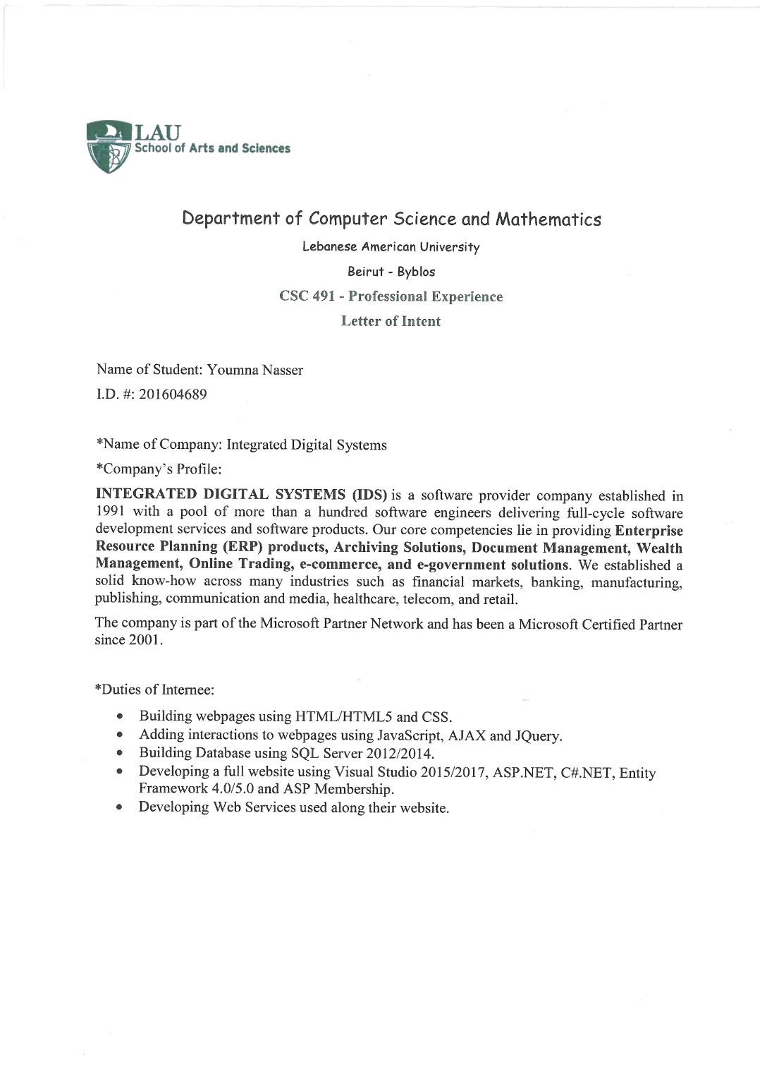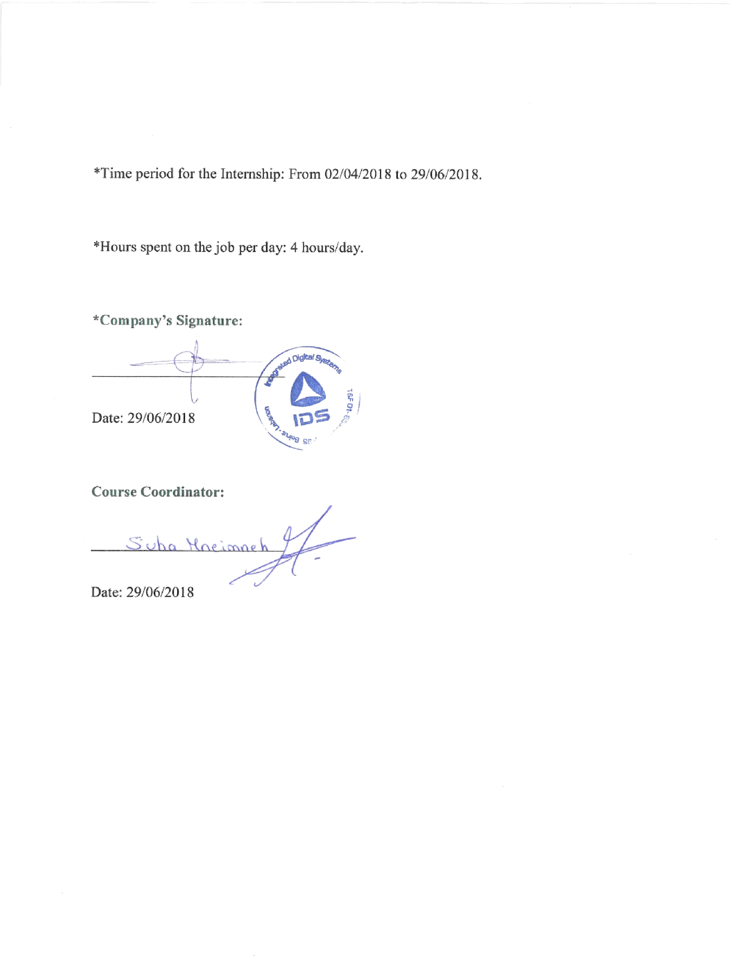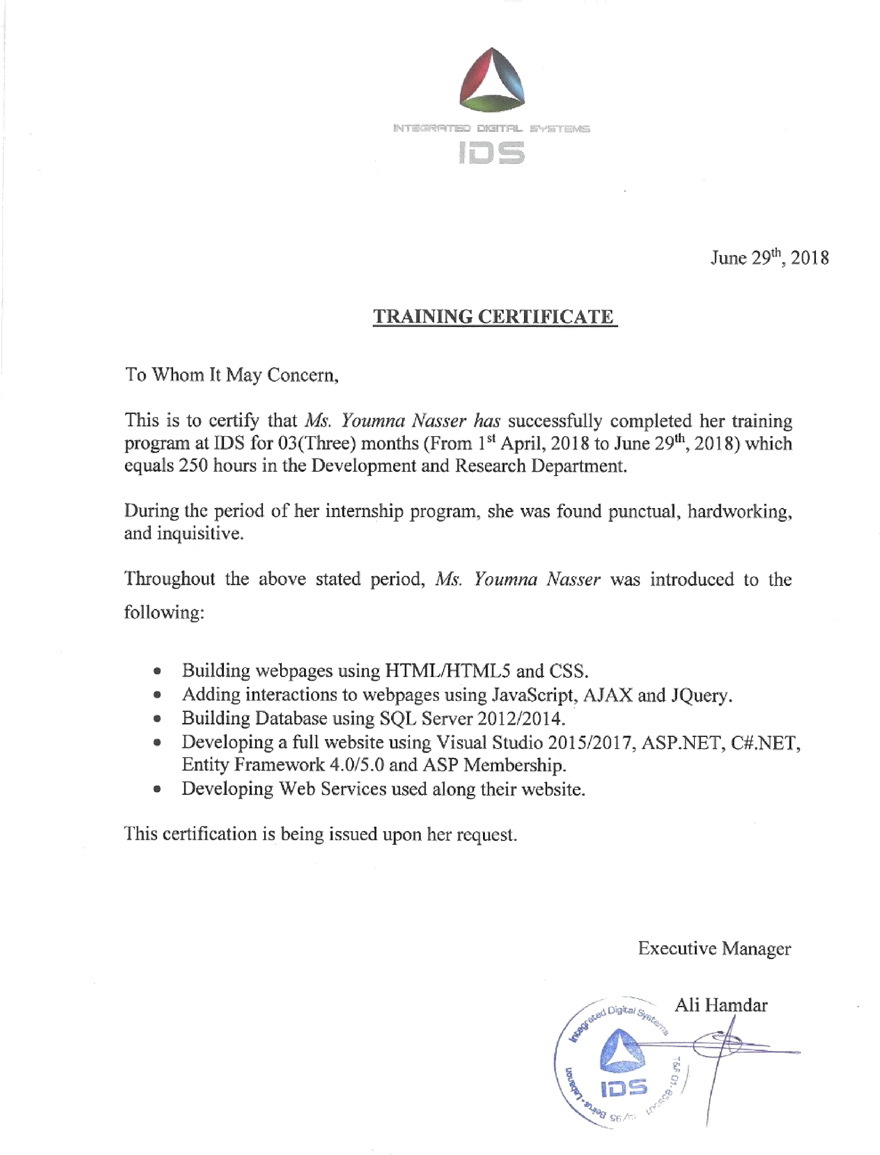

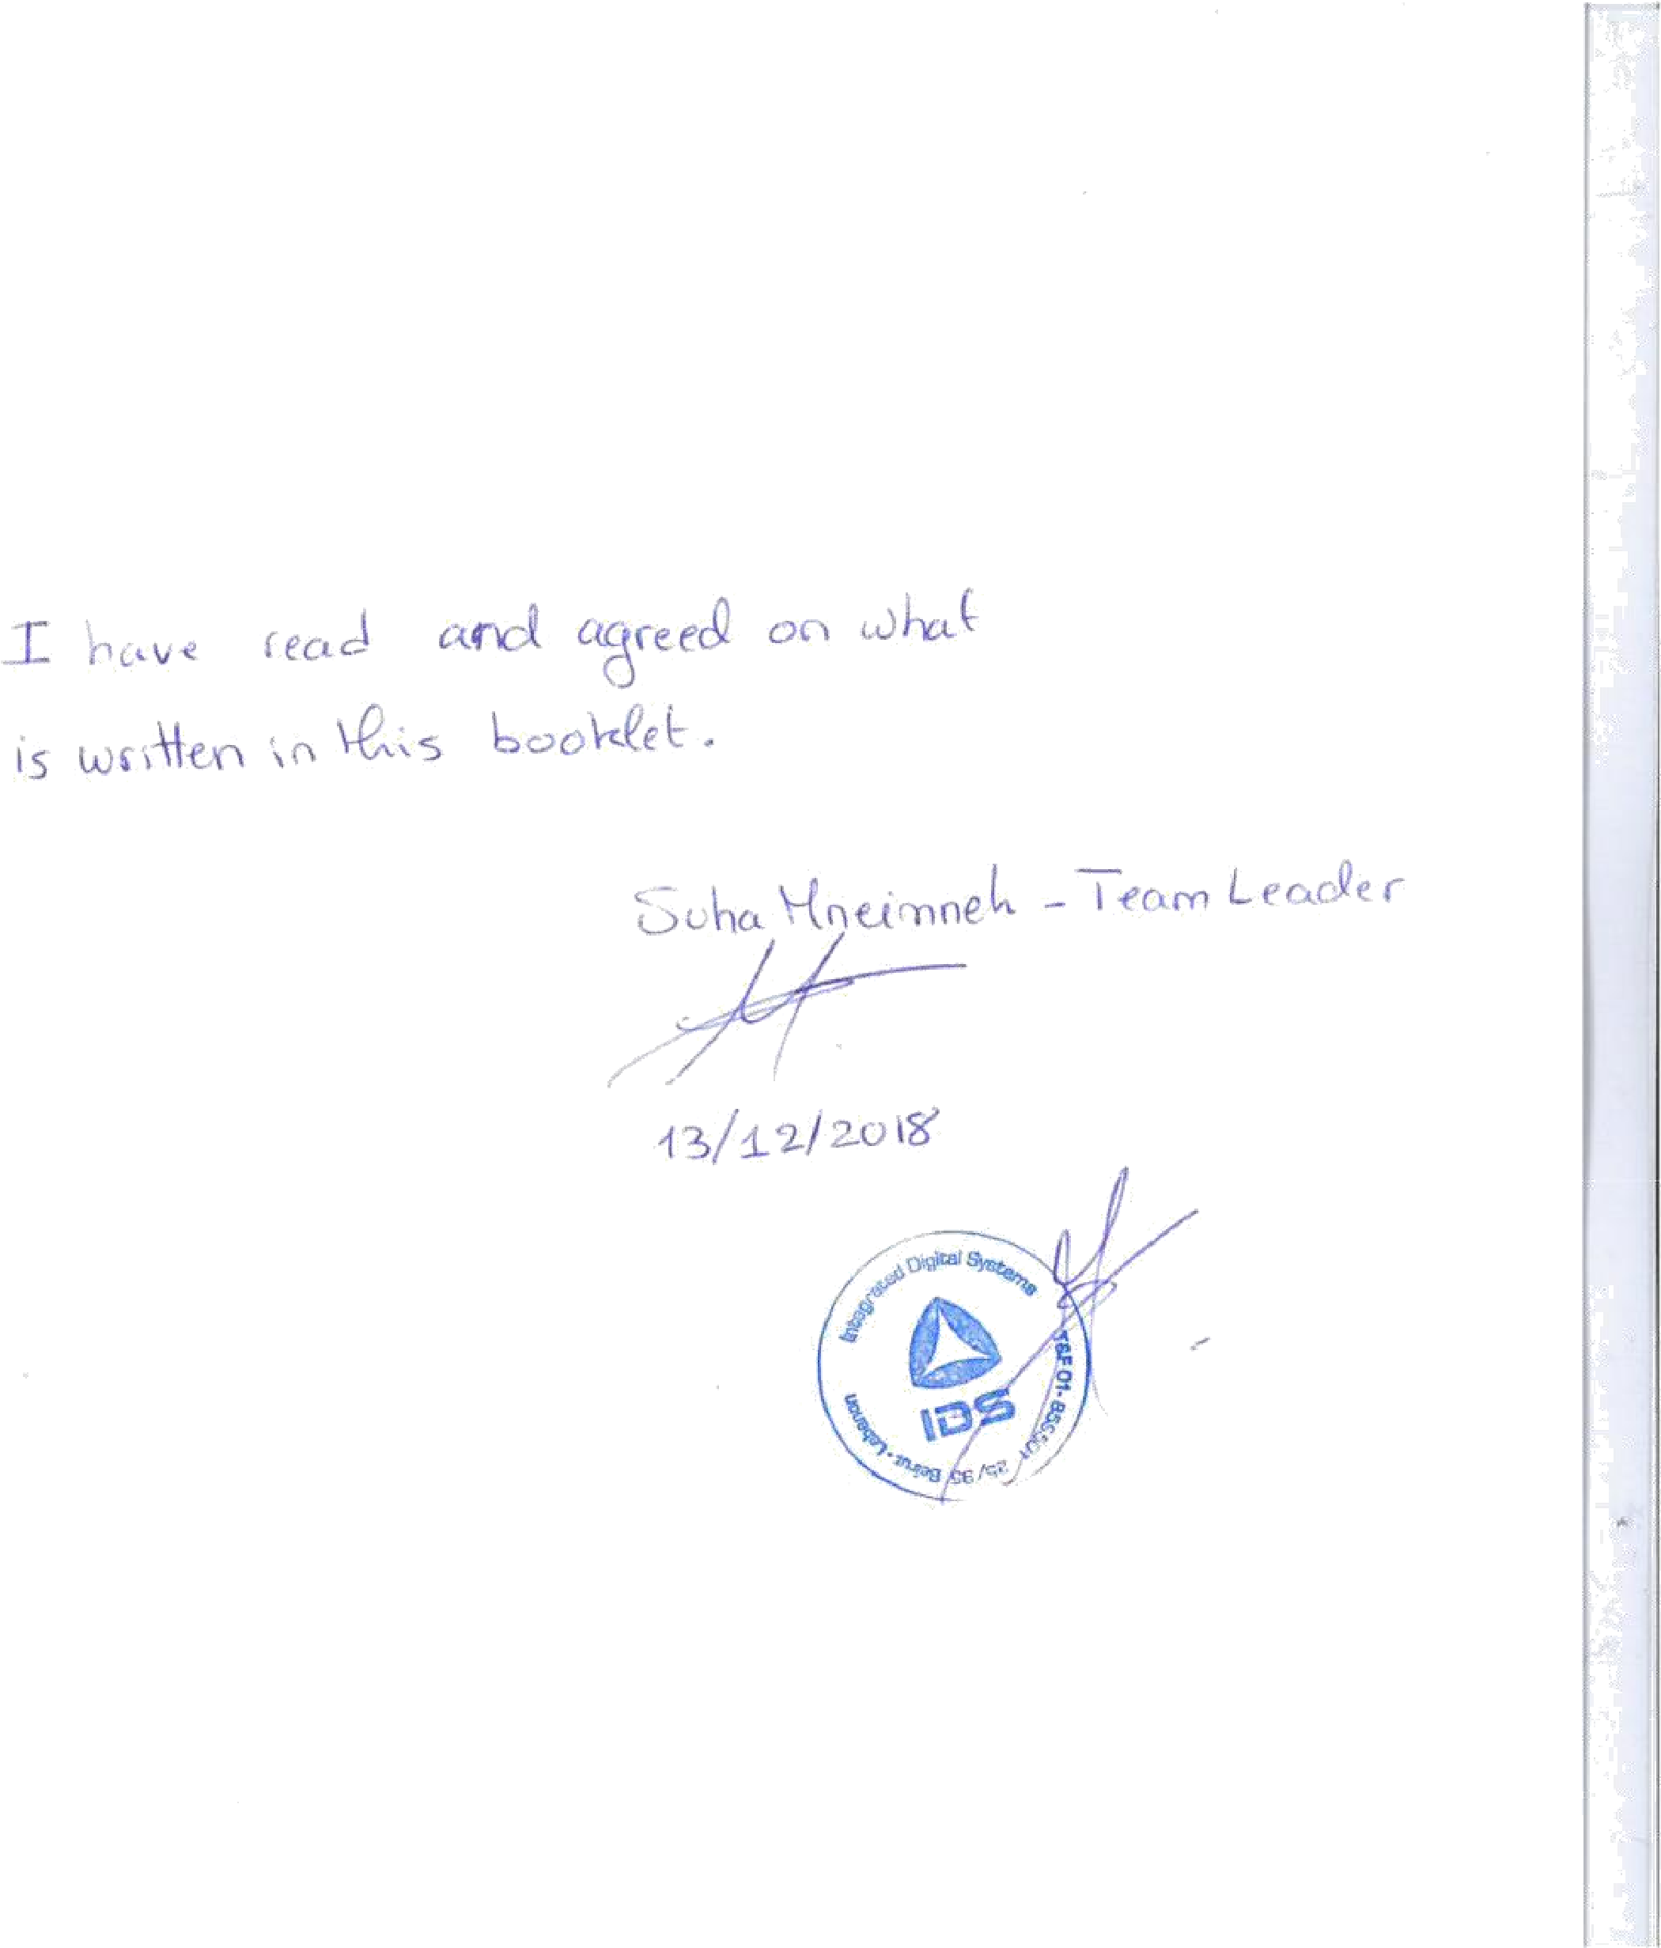

X.References

<http://www.entityframeworktutorial.net/what-is-entityframework.aspx>

[https://docs.microsoft.com/en-us/dotnet/framework/wcf/feature-details/how-to-use-the-aspnetmembership-provider](https://docs.microsoft.com/en-us/dotnet/framework/wcf/feature-details/how-to-use-the-aspnet-membership-provider) <http://www.ids.com.lb/who-we-are>

<https://github.com/NJ015/My_Internship>

<https://github.com/NJ015/MyAreebaInternship>

<https://aneagoie.github.io/robofriends/>

<https://robohash.org/2size=200x200%60>

<https://redux-toolkit.js.org/>

<https://redux-toolkit.js.org/tutorials/quick-start>

<https://www.typescriptlang.org/docs/handbook/typescript-from-scratch.html>

* <https://www.typescriptlang.org/docs/handbook/2/basic-types.html>
* <https://www.typescriptlang.org/docs/handbook/2/functions.html>
* <https://www.typescriptlang.org/docs/handbook/2/everyday-types.html>
* <https://www.typescriptlang.org/docs/handbook/2/objects.html>

<https://formik.org/docs/tutorial>

<https://medium.com/techvblogs/build-crud-api-with-node-js-express-and-mongodb-e3aa58da3915>

<https://mui.com/material-ui/getting-started/installation/>

<https://mui.com/material-ui/getting-started/learn/>

<https://medium.com/techvblogs/build-crud-api-with-node-js-express-and-mongodb-e3aa58da3915>

<https://formik.org/docs/tutorial>

<https://legacy.reactjs.org/docs/conditional-rendering.html#:~:text=Conditional%20rendering%20in%20React%20works,the%20UI%20to%20match%20them.&text=This%20example%20renders%20a%20different,the%20value%20of%20isLoggedIn%20prop>.

<https://jsonplaceholder.typicode.com/>

<https://react.dev/reference/react/hooks>

<https://redux.js.org/tutorials/fundamentals/part-1-overview>

<https://redux.js.org/tutorials/essentials/part-1-overview-concepts>

<https://react.dev/learn/managing-state>

<https://reactrouter.com/en/main/routers/create-browser-router#createbrowserrouter>

<https://www.freecodecamp.org/news/reactive-programming-beginner-guide/>

<https://legacy.reactjs.org/docs/create-a-new-react-app.html>

<https://nodejs.org/en>

<https://react.dev/learn/add-react-to-an-existing-project>

<https://react.dev/learn/installation>

<https://www.w3schools.com/js/js_string_search.asp>

<https://www.w3schools.com/js/js_string_methods.asp>

<https://www.w3schools.com/js/js_strings.asp>

<https://www.w3schools.com/js/js_arrays.asp>

<https://www.w3schools.com/js/js_array_methods.asp>

<https://www.w3schools.com/js/js_array_search.asp>

<https://www.w3schools.com/js/js_array_sort.asp>

<https://www.w3schools.com/js/js_switch.asp>

<https://www.w3schools.com/js/js_if_else.asp>

<https://www.w3schools.com/js/js_json.asp>

<https://www.w3schools.com/js/js_arrow_function.asp>

<https://www.w3schools.com/js/js_classes.asp>

<https://www.freecodecamp.org/news/top-javascript-concepts-to-know-before-learning-react/>

<https://www.w3schools.com/css/css_rwd_mediaqueries.asp>

<https://www.freecodecamp.org/learn/javascript-algorithms-and-data-structures-v8/>

<https://www.freecodecamp.org/learn/2022/responsive-web-design/#learn-html-by-building-a-cat-photo-app>

<https://flexboxfroggy.com/>

<https://www.figma.com/design/7UMHq4rNMaBHPwLUcxnJ11/Retail-E-Commerce-Website-Design-(Community)?node-id=3-447>